**Animal Health Care Services – Level- III**

**Based on March 2018, Version 3 Occupational Standards**

Description: bd07067_



**Module Title:** **Performing Pregnancy Test to Livestock**

**LG Code:** **AGR AHC3M17 LO (1-4) LG (65-68)**

**TTLM Code: AGR AHC3 TTLM 0621v1**

**June, 2021**

**Adama, Ethiopia**

Table of Contents

[LO # 1- Identify stages of pregnancy 4](#_Toc74200346)

[Instruction sheet 4](#_Toc74200347)

[Information sheet 1- Identify Fetal Development Change 5](#_Toc74200348)

[Self-check 1 - Written test 9](#_Toc74200349)

[Information sheet 2 - Identify Physical Change of Dam throughout gestation period 10](#_Toc74200350)

[Self-check 2 - Written test 14](#_Toc74200351)

[LO # 2- Prepare for pregnancy diagnosis procedures 15](#_Toc74200352)

[Instruction sheet 15](#_Toc74200353)

[Information sheet 1 - Completing pregnancy test preparation 16](#_Toc74200354)

[Self-check 1 - Written test 18](#_Toc74200355)

[Information sheet 2- Restraining, mustering and yarding animal safely 19](#_Toc74200356)

[Self-check 2 - Written test 22](#_Toc74200357)

[Information sheet 3 - Draft animals according to breeding or management program 23](#_Toc74200358)

[Self-check 3 - Written test 25](#_Toc74200359)

[Information sheet 4 - Prepare physical and human resources for pregnancy taste 26](#_Toc74200360)

[Self-check 4 - Written test 28](#_Toc74200361)

[LO # 3- Carry out pregnancy diagnosis 29](#_Toc74200362)

[Instruction sheet 29](#_Toc74200363)

[Information sheet 1- Use PPE 31](#_Toc74200364)

[Self-check 1 - Written test 33](#_Toc74200365)

[Information sheet 2 - Identify OHS hazards and risks and implement suitable controls 34](#_Toc74200366)

[Self-check 2 - Written test 36](#_Toc74200367)

[Information sheet 3 - Carry out pregnancy diagnosis 37](#_Toc74200368)

[Operation sheet 1 - Carrying out pregnancy diagnosis procedure 49](#_Toc74200369)

[LAP TEST - Performance Test 50](#_Toc74200370)

[Information sheet 4 - Identify stage of pregnancy 51](#_Toc74200371)

[Self check 4 - Written exam 54](#_Toc74200372)

[Information sheet 5 - Identify growth postural and positional abnormalities of pregnancy 55](#_Toc74200373)

[Self check 5 - Written test 57](#_Toc74200374)

[Information sheet 6 - Keeping Record 58](#_Toc74200375)

[Self check 6 - Written exam 59](#_Toc74200376)

[Information sheet 7- Disposing wastes 60](#_Toc74200377)

[Self check 7 - Written exam 61](#_Toc74200378)

[LO # 4- Carry out post pregnancy testing clean up procedure 62](#_Toc74200379)

[Instruction sheet 62](#_Toc74200380)

[Information sheet 1 - Identifying diagnosed animals as pregnant or not pregnant accurately 63](#_Toc74200381)

[Self check 1 - Written exam 65](#_Toc74200382)

[Information sheet 2 - Consigning all animals to their destination or return to pens/paddock 66](#_Toc74200383)

[Self check 2 - Written exam 67](#_Toc74200384)

[Information sheet 3 - Disposing debris and veterinary medicine containers in pregnancy testing procedures 68](#_Toc74200385)

[Self check 3 - Written exam 69](#_Toc74200386)

[Information sheet 4 - Carrying out regular monitoring of animals post testing evidence of physical damage or injury 70](#_Toc74200387)

[Self check 4 - Written exam 72](#_Toc74200388)

[References 73](#_Toc74200389)

|  |  |
| --- | --- |
| **LG #65** | LO # 1- Identify stages of pregnancy |

## Instruction sheet

This learning guide is developed to provide you the necessary information regarding the following content coverage and topics:

* + Identifying fetal development change
  + Identifying the physical change of dam

This guide will also assist you to attain the learning outcomes stated in the cover page. Specifically, upon completion of this learning guide, you will be able to:

* + Identify fetal developmental change throughout gestation period
  + Identify physical change of the dam throughout gestation period

**Learning Instructions:**

1. Read the specific objectives of this Learning Guide.
2. Follow the instructions described below.
3. Read the information written in the “Information Sheets”. Try to understand what are being discussed. Ask your trainer for assistance if you have hard time understanding them.
4. Accomplish the “Self-checks” which are placed following all information sheets.
5. Ask from your trainer the key to correction (key answers) or you can request your trainer to correct your work. (You are to get the key answer only after you finished answering the Self-checks).
6. If you earned a satisfactory evaluation proceed to “information sheets
7. If your performance is unsatisfactory, see your trainer for further instructions

|  |
| --- |
| Information sheet 1- Identify Fetal Development Change |

* 1. **Introduction**

All living organisms exhibit some form of growth and development. Members of the animal kingdom have the most complex developmental cycles of any living organism. The sequences of discrete, recognizable stages that these organisms pass through as they develop from the formation of a zygote (the fertilized egg) to the sexually mature adult are referred to as its developmental cycle. The growth of the individual from the formation of the zygote until birth is a continuous process; however, the prenatal period can be divided into certain phases of development without altering the basic concept of continuity. These phases can be designated according to the size of the individual as measured by length, volume, weight, or a combination of these measures. Animal development can be subdivided into several sequential processes. There are two phases of animal development period. These are prenatal and post-natal (post-parturition) period. The prenatal period is usually divided into three major periods, namely: ovum, embryonic, and fetal, based upon some of the more critical moments in the individual's life as well as upon the amount of development.

Definition of terminologies

* Gametogenesis: refers to the process of gamete production – oogenesis in the ovarioan follicles and spermatogenesis in the testicular seminiferous tubules
* Fertilization: is the process in which gametes (an egg and sperm) fuse to form a zygote
* Conception: Conception is the point in time when the sperm fertilizes the ova
* Gestation: The time an animal is pregnant
* Embryo: is early developmental stage of an animal within the uterus of the dam
* Fetus: is the stage of development between embryonic stage up to birth
* Parturition: The act of giving birth by female mammals
* Dam: is the mother of an animal

Division of Prenatal Periods

* Ovum period:- The period from fertilization until implantation or attachment is usually known as the period of the ovum.
* Embryonic period:-The embryonic period begins at the time the embryo attaches itself to the wall of the uterus. It is usually considered as the time during which the major' tissues, organs, and their systems are formed. While most of these alterations are internal, at the same time the body shape of the individual undergoes a series of successive changes. Embryonic period lasts for up to 30 days in dog, cat, sheep and pig but 60 days in horse, cattle and human.
* Fetal Period:- The fetal period begins 9 weeks after fertilization and ends at birth in bovine. It is characterized by being a period of rapid body growth and maturation of organs and systems.
  1. **Bovine fetal Development Change throughout gestation period**

At first, the fetus increases its length more rapidly than it gains weight. In the third trimester of gestation, the length increases slowly increasing rapidly in weight. The energy requirements of the fetus increase from the third trimester of gestation. Fetus size varies according to genetic factors, such as race, fetus phenotype, and other environmental factors, such as the mother’s age, nutrition, and management.

Fetal development essentially provides the template for postnatal growth characteristics of adult animal. Bovine fetal growth was primarily determined by genetic constraints imposed during fetal development but influenced by maternal factors. Following implantation the conceptus secretes Interferon tau (IFNT) that is the signal for maternal recognition of pregnancy (Day 16). This maintains progesterone (P4) secretion and antagonizes the endometrial cells response to phorbol 12, 13-dibutyrate (PDBU) an activator of protein kinase C. Implantation in the uterus occurs between 30-35 days. Pregnancy appears to occur more commonly in the right uterine horn than in the left at a ratio of 60: 40, with the corpus luteum typically being on the same side, reﬂecting the slightly more active right ovary.

Differences in the development of organs and muscles in the fetus were expected between dairy and meat cattle. Furthermore, the muscle development in double muscled cattle compared with normal cattle is obvious at birth. Fetal development change throughout gestation period in bovine species is described below.

* First month (28 days) - The embryonic period, the embryo is 9 to 10 mm long and the first signs of extremities appear.
* Second month (30 to 60 days) - The extremities develop. The pharyngeal cleft closes in the beginning of this month. The sternum still has a longitudinal fissure in the middle, closing toward the end of the eighth week. At the end of the second month at the end of each extremity is a little conical elevation, which is colorless and transparent. This is the first indication of the hoof. The length of the fetus is 48 mm In the ninth week its length is 8 cm.
* Third month (60 to 90 days) - Toward the end of this month the four stomachs may be recognized. The fetus measures 14 cm in length. The scrotum is present.
* Fourth month (90 to 120 days) - In the beginning of the fourth month the hoofs become quite, distinct; they are firm, non-transparent, and have a yellow color. The fetus is about 24 cm. long and weighs up to 2 kg.
* Fifth month (120 to 150 days) - In the beginning of the month the first tentaculse (tactile hairs) appear on the lips, chin, upper eyelid, and orbital arch. The teats are plainly visible. The testicles descend into the scrotum. The fetus, is about 35 cm long and weighs 2.5 to 3 kg.
* Sixth month (150 to 180 days) - The eyelashes are more developed. The foetus is about 46 cm long. The whole body is still naked excepting the lips and eyelids.
* Seventh month (180 to 210 days) - At the end of this month a few long hairs appear at the end of the tail; also hairs about the coronet and on the spots where the horns appear. The foetus is about 60 cm. long.
* Eighth month (210 to 240 days) - The back begins to be covered with hair, also along the edges of the ears. The length of the fetus toward the 32d week is 65 cm, and toward the end of this month 75 cm.
* Ninth month - In the beginning the whole body is covered with hair and increases greatly in size. The fetus measures from 80 to 100 cm and fetus become matured.
  1. **Gestation Periods of animals**

Gestation is the time interval between fertilization of an egg and the birth of the young. It begins at fertilization and ends with parturition. Gestation lengths vary in different species. The uterus, the ovaries, and the whole of the tissues of the mother are influenced directly or indirectly during pregnancy, but the gross changes exhibited, with certain exceptions, subside quickly after the birth of the young. The minor alterations which persist throughout life, such as increased size of the mammary glands, enlargement of the uterus, and of the whole of the genital canal, are not generally obvious except after repeated breeding, and in from 4 to 6 weeks the dam has returned to normal to all intents and purposes, always excepting the flow of milk in the mammary glands.

Table 1: Gestation periods of different species of animals

|  |  |  |
| --- | --- | --- |
| Animal species | Average periods | |
| Months | Days |
| Cow | 9 | 283 - 284 |
| Ewe and goat | 5 | 144-150 |
| Mare | 11 | 340 |
| Sow | - | 114 |
| Bitch | - | 55-63 |

The gestation period is a period of development and there is a continuous process of tissue differentiation, organogenesis and maturation. The process is complex, and critical periods of development occur at different times in the different species.

|  |
| --- |
| Self-check 1 - Written test |

**Directions:** Answer all the questions listed below. Use the Answer sheet provided in the next page:

**Test 1. Choose the best answer** (4 points)

1. The act of giving birth by female mammals is termed as:
2. Gestation period b. gametogenesis c. parturition
3. Implantation in the uterus occurs between \_\_\_\_\_\_\_days after last conceptions in bovine species
4. 16- 18 days b. 30-35 days c. 45 days d. 60 days

**Test II. Short answer questions**

1. Give the definition of gestation periods? (2points)
2. Write the three development periods of pregnancy?(3points)
3. Explain fetal development change throughout gestation period? (3points)

***Note:* Satisfactory rating – 6 points Unsatisfactory - below 6 points**

Yo

u can ask you teacher for the copy of the correct answers.

You can ask your teacher for the copy of the correct answers.

**Answer Sheet**

Score = \_\_\_\_\_\_\_\_\_\_\_

Rating: \_\_\_\_\_\_\_\_\_\_\_\_

Name…………………………………………… ID………………………… Date…….

|  |
| --- |
| Information sheet 2 - Identify Physical Change of Dam throughout gestation period |

* 1. **Physical Change of Dam throughout gestation period**

**2.1 Introduction**

Pregnant animals show various physical and hormonal changes throughout gestation period. The physical change of dam throughout gestation period includes observation of the following signs on pregnant animals.

* Ballottement: The abdomen of the pregnant animal begins to become distended from about seven months of gestation. If a hand is pushed ﬁrmly against the right side of the abdomen, the fetus may sometimes be felt to rebound against it. This technique is commonly used in cattle markets by prospective purchasers. However, it is not a reliable indicator of pregnancy particularly if the ﬁndings are negative. Slight vaginal discharge (from 4-5 months onward in dairy cows) and movements of the fetus visible externally.
* Mammary gland development: Mammogenesis or development of the mammary gland occurs as a consequence of pregnancy. In the primiparous heifer changes can be detected as early as four months of gestation. In addition, a viscous brown secretion may be expressed from the teats. Of course, these changes are not apparent in the parous, lactating cow. Steroidal-type growth promoters can elicit identical changes in the mammary glands of heifers. This can be an additional confounding factor in countries and situations where they are used. It is only during the last few days of pregnancy when the udder becomes distended with colostrum that mammary development can be regarded as an accurate diagnosis of pregnancy.

Other physical changes observed on dam are:

* Fattening tendency particularly during early pregnancy.
* Gradual increase in body weight.
* Flanks become hollow and spine appears more prominent.
* The size of mammary glands or udder begins to increase from about 5th months of gestation in heifers, while in older cows it is usually observed just 2-3 weeks before parturition.

**2.2 Reproductive Physiology**

Parts and Functions of the Female Livestock Reproductive System

**Ovaries**

* Function: Produce ova called eggs. Two oval shaped organs located near the end of the reproductive tract inside the body cavity.
* Forms corpus luteum
* Secretes estrogen hormone

**Oviducts**

* Carry the eggs from the ovaries to the uterus
* Also called the fallopian tubes
* Small tubes that are near but not attached to ovaries
* Have small funnel-shaped end near the ovary

**Uterus (womb)**

* Place where fetus grows and develops
* Organ with two branched horn-shaped attachments called uterine horns
* Will have a baby inside if animal is pregnant

**Cervix**

* Serves as a passageway for sperm to travel from the vagina to the uterus
* Seats the uterus during pregnancy to prevent pathogens from affecting fetus
* Thick walled structure made up of folds and rings of muscular tissue
* Located at the neck of uterus
* Separates the uterus from the vagina

**Vagina**

* Receives the male penis and sperm at breeding
* Serves as a passageway for the baby to pass through at birth
* Serves as a passageway for urine to be expelled

**Vulva**

* External opening to female reproductive and urinary systems
* External opening made up of folds of skin

**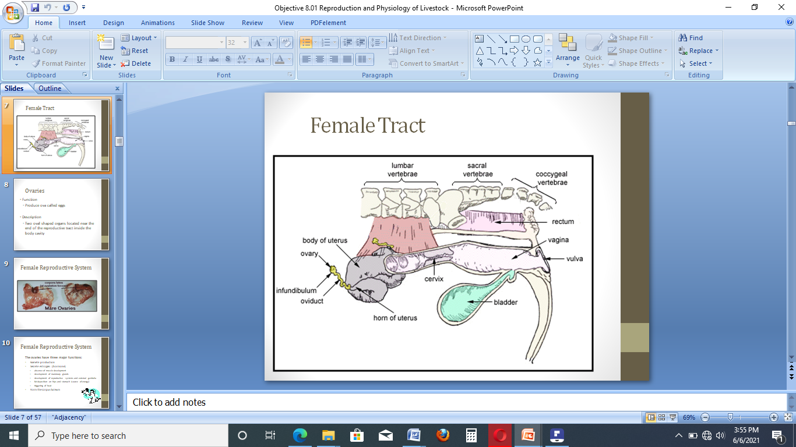**

**Figure 1**: Female Reproductive Tract

Female puberty is characterized by the first oestrus with ovulation. Thus, puberty refers only to the early reproductive life of the female, but for the introduction of heifers in reproduction, it is important that they have reached sexual maturity regarding body development in order to avoid possible complications during childbirth. Heavier heifers reach puberty at younger ages. The development of the reproductive tract is a useful tool for the evaluation of puberty in heifers.

|  |
| --- |
| Self-check 2 - Written test |

**Directions:** Answer all the questions listed below. Use the Answer sheet provided in the next page:

**Short answer questions**

1. What are the physical changes of the dam during gestation period?(3points)
2. List and describe function of female reproductive tract(3points)

***Note:* Satisfactory rating - 3points Unsatisfactory - below 3 points**

You can ask you teacher for the copy of the correct answers.

You can ask your teacher for the copy of the correct answers.

**Answer Sheet**

Score = \_\_\_\_\_\_\_\_\_\_\_

Rating: \_\_\_\_\_\_\_\_\_\_\_\_

Name…………………………………………… ID………………………… Date…….

|  |  |
| --- | --- |
| **LG #66** | LO # 2- Prepare for pregnancy diagnosis procedures |

## Instruction sheet

This learning guide is developed to provide you the necessary information regarding the following content coverage and topics:

* Completing pregnancy tasting preparation
* Restraining mustering, yarded animal safely
* Drafting animals to be tested for breeding
* Preparing human and physical resource for pregnancy taste

This guide will also assist you to attain the learning outcomes stated in the cover page. Specifically, upon completion of this learning guide, you will be able to:

* Complete pregnancy testing preparations including relevant document
* Restrain, muster and yard animals safely
* Identify animals for pregnancy test according to breeding or management program
* Identify resources required for pregnancy diagnosis

**Learning Instructions:**

* + - 1. Read the specific objectives of this Learning Guide.
      2. Follow the instructions described below.
      3. Read the information written in the “Information Sheets”. Try to understand what are being discussed. Ask your trainer for assistance if you have hard time understanding them.
      4. Accomplish the “Self-checks” which are placed following information sheets.
      5. Ask from your trainer the key to correction (key answers) or you can request your trainer to correct your work. (You are to get the key answer only after you finished answering the Self-checks).
      6. If you earned a satisfactory evaluation proceed to the next information sheet
      7. If your performance is unsatisfactory, see your trainer for further instructions

|  |
| --- |
| Information sheet 1 - Completing pregnancy test preparation |

* 1. **Pregnancy testing preparation**

What is pregnancy diagnosis?

To maintain a successful cow-calf operation, it is necessary for the producer to have a high-percentage calf-crop each year that offsets the maintenance cost for all cows. Pregnancy diagnosis is also called ‘pregnancy determination’. It is usually shortened as PD. PD by means of rectal palpation is an art. Like any art, it requires considerable guidance before it is mastered and then more or less constant practice in order to maintain proficiency. There are three reasons why PD is important:

* With PD we can identify and combat fertility problems in herds or individual cows at as early a stage as possible.
* With PD we can identify non-pregnant cows and they can then be culled if desirable. In this way PD assists economy and efficiency.
* With PD we can certify that a cow is pregnant; this is important where cows are bought or sold.

Need for pregnancy diagnosis

* Improving reproductive performance
* Earlier the pregnancy diagnosis performed, the more profitable is the return for dairy cows
* Management
* Feeding
* Sale
* Improve record keeping data
* Inform decisions on individual cows

For cattle producers, it is economically important for cow-calf operations to be as efficient as possible. Pregnancy testing preparation requires knowledge and skill of anatomy and physiology female reproductive tract and necessary equipments.

|  |
| --- |
| Self-check 1 - Written test |

**Directions:** Answer all the questions listed below. Use the Answer sheet provided in the next page:

**Short answer questions**

1. Define pregnancy diagnosis?(1points)
2. Explain need of pregnancy diagnosis(3points)

***Note:* Satisfactory rating – 2 points Unsatisfactory - below 2 points**

You can ask you teacher for the copy of the correct answers.

You can ask your teacher for the copy of the correct answers.

**Answer Sheet**

Score = \_\_\_\_\_\_\_\_\_\_\_

Rating: \_\_\_\_\_\_\_\_\_\_\_\_

Name…………………………………………… ID………………………… Date…….

|  |
| --- |
| Information sheet 2- Restraining, mustering and yarding animal safely |

* 1. **Animal Restraining**

Animal restraint or handling is one of the most important skills a technician and assistant should possess. Good cattle handlers or restrainer learn these skills through observation and trial and error. Good cattle handling saves time and effort, and reduces stress for people and animals. Working with cattle may be dangerous, especially in yards, races and dairy sheds where people and cattle are close together. High risk activities include working with bulls and with cows and newborn calves. Being a master at restraint is a trait that will be valued in a veterinary clinic.

The animal to be examined should be properly restrained. Cows and buffaloes can be securely restrained in a Travis or chute. At many situations when this is not available the hind legs of cows are tied with a rope to avoid kicking and the head is held securely. The tail is held to one side by an assistant. Pressing on the back relaxes the pelvic structures and reduces peristalsis.

Animal health providers and animal owners are also faced with everyday animal handling related problems like physical injuries, death and zoonosis. Proper restraint and handling techniques reduce stress to the animals and to the handler. Also calm, quiet handling of animals makes the handler safer. Restraining can be effected by using various devices such as halters, head-collars, twitches, muzzles, gags, side lines, hobbles, etc. The cow’s head should not be placed in a stanchion or head gate, as this tends to excite the cow. If the chute’s floor is concrete or wood, then cleats or cross-slats should be constructed to prevent the cow from slipping.

A cow, but particularly a beef cow, is often aggressive just after calving. Livestock handlers should remember:

* The younger the calf means that the mother may be more dangerous
* To avoid having a dog with them when doing work involving cows with calves
* To avoid situations where they come between a cow and her newborn calf without some form of barrier for protection this is especially important when weighing and applying identification to a newborn calf.
* Give cattle time to settle after they have been mustered into yards or unloaded from a truck. A 30 minute rest is a useful rule of thumb.
* Feed cattle in the yards, especially following weaning and move them quietly through the yards so they become easier to handle in the future.
* Fill cattle yard pens approximately one quarter to one half full. For example, if a pen can fit 40 animals, only put 10-20 cattle in.

**2.2 Mustering and yarding animal safely**

Yards should be maintained in a workable condition. This will help to protect livestock handlers and livestock when using the yards.

Livestock handlers should:

* regularly inspect the yards
* inspect the yards before they are used, and
* action maintenance issues discovered during use of the yards.

General suggestions for improving yard safety include:

* Yards, crushes, cradles and sheds should be suitable in size and strength for the animals being handled.
* Avoid blind corners and sharp turns in the design of your yard.
* Keep the walkways and laneways dry and non-slip wherever possible.
* Make sure your gates, footholds and access ways are well positioned.
* Keep all equipment in good repair: gates moving and hung, latches working, hinges greased.

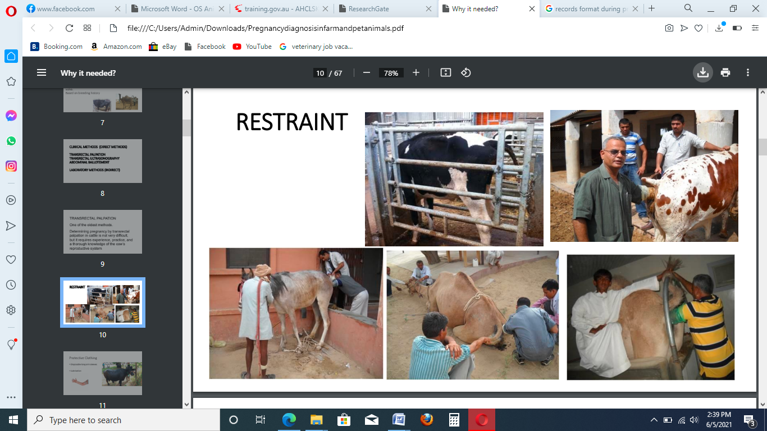

**Figure 2:** Restraining technique of domestic animals during pregnancy diagnosis

|  |
| --- |
| Self-check 2 - Written test |

**Directions:** Answer all the questions listed below. Use the Answer sheet provided in the next page:

**Short answer questions**

1. Explain animal restraining technique used in pregnancy diagnosis(2points)
2. Write the difference between yards and animal handling pens(2points)

***Note:* Satisfactory rating - 2points Unsatisfactory - below 2 points**

You can ask you teacher for the copy of the correct answers.

You can ask your teacher for the copy of the correct answers.

**Answer Sheet**

Score = \_\_\_\_\_\_\_\_\_\_\_

Rating: \_\_\_\_\_\_\_\_\_\_\_\_

Name…………………………………………… ID………………………… Date…….

|  |
| --- |
| Information sheet 3 - Draft animals according to breeding or management program |

**2.3 Draft animals according to breeding or management program**

Breed refers to a group of animals within a species which have certain characteristics in common which makes the individual of that breed recognizable as such. A Breeding program is a program aiming at defined breeding objectives for the production of a next generation of animals. It is the combination of recording selected traits, the estimation of breeding values, the selection of potential parents and a mating programme for the selected parents including appropriate (artificial) reproduction methods.

The choice of the most appropriate breed to use in a given environment or production system should be the first step when initiating a breeding program and due attention should be given to the adaptive performance of a breed. Selective animal breeding already has almost 300 years of history. The size of the genetic improvement from generation to generation depends on the technique used to select animals for breeding.

Pregnancy diagnosis is an important tool to measure the success of reproductive management of a cattle herd. For the selective breeding to be successful it is essential that the trait (e.g. running speed or milk production or coat colour) under selection is heritable. The animals should have different genetic backgrounds so that selection is possible. The direction of selection is defined by humans and they decide which animals are allowed to mate and produce members of the next generation.

Breeding activities are directly be influenced by and are related to developments in society: required food production by animals and requirements of mankind for animals as companion and for leisure purposes.

Breeding programs with cattle, pigs and poultry yielded sharp increases in the quantity of milk, meat or eggs. In those developing countries animals are kept for multiple purposes: to produce food, labour (traction power), warmth, for their hides and/or wool, their manure is used as fertiliser for the land and also as fuel for the fire, as savings account (sell an animal when needed), and to increase social status (more is better). However, an increasing number of selective breeding programs has been developed in a large range of countries, and many are quite successful.

An accurate, early diagnosis of pregnancy is essential to a successful breeding program. In both beef and dairy cattle, pregnancy diagnosis is an important tool to measure the success of a reproductive management, to allow for early detection of problems and to achieve resynchronization of non-pregnant cows.

Pregnancy diagnosis is essential for profitable animal husbandry particularly in the productive animal species. Early pregnancy diagnosis would help to evaluate the therapies at an early date and devise alternative manipulations in the current systems of planned breeding. Furthermore, early diagnosis of pregnancy is essential in animal management for economic reasons. Early identification of non-pregnant dairy cows and heifers post breeding can improve reproductive efficiency and pregnancy rate by decreasing the interval between AI services and increasing AI service rate.

A changing cattle industry may affect how pregnancy diagnoses are performed in the future Intensification of reproductive management in beef herds and the implementation of AI are creating the need for more accurate and timely diagnoses of pregnancy.

|  |
| --- |
| Self-check 3 - Written test |

**Directions:** Answer all the questions listed below. Use the Answer sheet provided in the next page:

**Short answer questions**

1. Write the importance of early pregnancy diagnosis in animal breeding(3points)
2. Describe pregnancy diagnosis test of animal to draft for breeding program(3points)

***Note:* Satisfactory rating – 3 points Unsatisfactory - below 3 points**

You can ask you teacher for the copy of the correct answers.

You can ask your teacher for the copy of the correct answers.

**Answer Sheet**

Score = \_\_\_\_\_\_\_\_\_\_\_

Rating: \_\_\_\_\_\_\_\_\_\_\_\_

Name…………………………………………… ID………………………… Date…….

|  |
| --- |
| Information sheet 4 - Prepare physical and human resources for pregnancy taste |

**2.4 Physical and human resources required for pregnancy diagnosis**

Pregnancy diagnosis is unreliable and slow when unskilled or semi-skilled persons attempt to do it. At the same time it is costly under such conditions. For these reasons it is usually more economical to hire a skilled and reputable person to do Pregnancy diagnosis than to attempt to do it otherwise. An additional advantage is (when a professional does the job) that veterinary service is available when it is needed. Pregnancy diagnosis requires a great deal of skill and experience.

Little equipment is needed in palpation. The palpator should wear a protective plastic sleeve that covers the arm and hand up to the shoulder. The sleeve guards against disease and prevents irritation of the arm. Use an obstetrical lubricant or mineral oil to make entry into the rectum easier. Don’t use soap or detergents as a lubricant, since both are irritants. Plastic sleeves may tear after several uses, reducing protection. If the sleeve tears, replace it before palpating the next animal.

Equipment necessary for pregnancy diagnosis

* Protective Covering for the Palpator: Because the palpator must insert the hand and arm into the cow’s rectum, it is necessary to cover those body parts. Plastic sleeves are used for that purpose.
* Lubricant (Disinfectants):A lubricant is applied to the covered hand and arm to facilitate entry into the cow’s rectum. Commercial obstetrical lubricants are available at farm and ranch supply stores. Liquid soap can also be used as a lubricant, because it provides a slick covering over the arm and does not irritate the cow’s rectal cavity as do some detergents.
* Chute**:** A holding chute will allow the cow to stand on the ground in a normal position to prevent any unnecessary physical stress. A gate or brace in front of the cow will prevent her forward movement. A pipe or pole should be inserted through the chute behind the cow’s legs and approximately four inches above the hocks. The pipe or pole keeps the palpator from being kicked and also prevents the cow from backing. An entrance gate alongside the chute should open to the inside of the chute to close off other cows behind the cow being palpated.

Other equipments used for pregnancy diagnosis are:

* + - * Animal crate
      * Thermometer
      * stethoscope

|  |
| --- |
| Self-check 4 - Written test |

**Directions:** Answer all the questions listed below. Use the Answer sheet provided in the next page:

**Short answer questions**

1. List equipments necessary for pregnancy diagnosis (3 points)
2. What arrangements are required before conducting pregnancy diagnosis (2 points)
3. Write the importance of using lubricant in animal pregnancy diagnosis(3 points)

***Note:* Satisfactory rating – 4 points Unsatisfactory - below 4 points**

You can ask you teacher for the copy of the correct answers.

You can ask your teacher for the copy of the correct answers.

**Answer Sheet**

Score = \_\_\_\_\_\_\_\_\_\_\_

Rating: \_\_\_\_\_\_\_\_\_\_\_\_

Name…………………………………………… ID………………………… Date…….

|  |  |
| --- | --- |
| **LG #67** | LO # 3- Carry out pregnancy diagnosis |

## Instruction sheet

This learning guide is developed to provide you the necessary information regarding the following content coverage and topics:

* Using PPE.
* Identifying and assessing OHS hazards and risks
* carrying out Pregnancy diagnoses
* Identifying stage of pregnancy
* Identifying growth postural and positional abnormalities of pregnancy
* Keeping Records
* Disposing waste

This guide will also assist you to attain the learning outcomes stated in the cover page. Specifically, upon completion of this learning guide, you will be able to:

* Identify and use PPE
* Identify, assess risk and apply control measures
* Carry out pregnancy diagnosis following procedures
* Identify stage of pregnancy
* Identify growth postural and positional abnormalities of pregnancy in animals
* Keep and report records
* Dispose waste according to recommended hygienic standards

**Learning Instructions:**

Read the specific objectives of this Learning Guide

Follow the instructions described below

Read the information written in the “Information Sheets”. Try to understand what are being discussed. Ask your trainer for assistance if you have hard time understanding them

Accomplish the “Self-checks” which are placed following information sheets

Ask from your trainer the key to correction (key answers) or you can request your trainer to correct your work. (You are to get the key answer only after you finished answering the Self-checks)

If you earned a satisfactory evaluation proceed to next Operation sheets

Perform “the Learning activity performance test” which is placed following “Operation sheets” ,

If your performance is satisfactory proceed to the next learning guide,

If your performance is unsatisfactory, see your trainer for further instructions or go back to “Operation sheets”.

|  |
| --- |
| Information sheet 1- Use PPE |

* 1. **Personnel Protective Equipment (PPE)**

The occupational health and safety program provides guidelines designed to protect employees from the hazards associated with the care of animals. However, the primary responsibility for maintaining good health and safety lies with each individual. Personnel should always follow safety guidelines and exercise common sense.

Personal protective equipment PPE refers to equipment used as a barrier between an individual and a hazard that could result in an injury or occupational illness. All equipment (including clothing affording protection against the weather) which is intended to be worn or held by a person at work which protects them against one or more risks to their health and safety.

Because the palpator must insert the hand and arm into the cow’s rectum, it is necessary to cover body parts.

There are different PPE used during pregnancy diagnosis. These are:

* Coveralls
* gum boots
* disposable plastic or rubber full arm sleeves(arm length gloves)
* Separate trousers and shirts
* Plastic long sized aprons
* respirator or face mask
* sun protection (sun hat, sun screen)

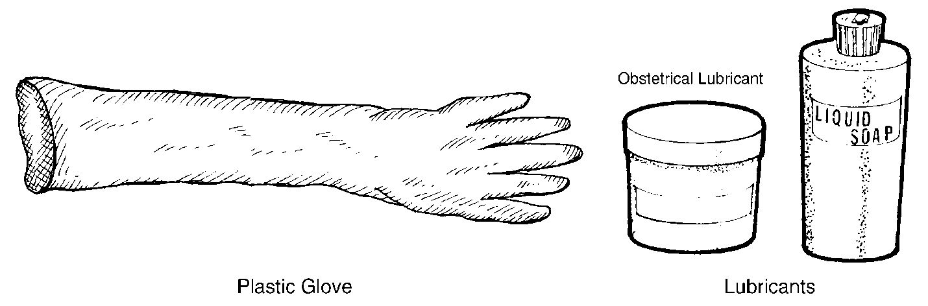

**Figure 3:** Some example of PPE used in pregnancy diagnosis

|  |
| --- |
| Self-check 1 - Written test |

**Directions:** Answer all the questions listed below. Use the Answer sheet provided in the next page:

**Short answer questions**

1. Define personal protective equipment(2 points)
2. List PPE required during pregnancy diagnosis in animals(4 points)

***Note:* Satisfactory rating – 3 points Unsatisfactory - below 3 points**

You can ask you teacher for the copy of the correct answers.

**Answer Sheet**

Score = \_\_\_\_\_\_\_\_\_\_\_

Rating: \_\_\_\_\_\_\_\_\_\_\_\_

Name…………………………………………… ID………………………… Date…….

|  |
| --- |
| Information sheet 2 - Identify OHS hazards and risks and implement suitable controls |

* 1. **Identify OHS hazards and risks in the work place**

There are numerous hazards besides animal contact that present a risk to livestock handlers on the farm or ranch. Scratches and kicks are ever-present hazards associated with pregnancy diagnosis activities in animals and work with related equipment. Employees should be properly trained in animal handling, general restraint techniques, and environmental factors for the species they will work with. In addition, all staff should be familiar with first aid procedures specific to each species and the incident reporting process. Falls and slips on farms and ranches from slippery surfaces or stepping in holes or uneven surfaces are often recorded as being in the top three leading causes of farm injuries. Exposure to noise on farms is common. Zoonoses are any infectious diseases that can be transmitted from non-human animals to humans or from humans to non-human animals. Farm animals still can be infected with zoonotic agents, some of which can be life-threatening to humans especially if contact animals without using PPE.

Other safety issues veterinarians and cattle producers should be aware of Work safe

* Keep cattle and people separate.
* Keep children away from the cattle yards.
* Employ or generate experienced and trained staff.
* Sign post areas clearly.
* Provide adequate lighting.
* Do not let he pen or crush floor to build up as this reduces the height of the fence.
* First aid kits should be readily available.

**Risk Assessment:**

* Learn about the animals you work with
* Review work tasks for potential hazards

**Risk preventive measures**

* Complete required training
* Know how to protect yourself against hazards in your work area
* Read and follow all safety signs and instructions in animal areas
* Use appropriate protective clothing
* Apply appropriate restraining technique for animals conducting pregnancy diagnosis

|  |
| --- |
| Self-check 2 - Written test |

**Directions:** Answer all the questions listed below. Use the Answer sheet provided in the next page:

**Short answer questions**

1. Define work place hazards and risks?(2 points )
2. Explain risk preventive measure in the work place(2 points)

***Note:* Satisfactory rating – 2 points Unsatisfactory - below 2 points**

You can ask you teacher for the copy of the correct answers.

You can ask your teacher for the copy of the correct answers.

**Answer Sheet**

Score = \_\_\_\_\_\_\_\_\_\_\_

Rating: \_\_\_\_\_\_\_\_\_\_\_\_

Name…………………………………………… ID………………………… Date…….

|  |
| --- |
| Information sheet 3 - Carry out pregnancy diagnosis |

**3.3 Conduct pregnancy diagnosis in livestock**

The period from the date of conception to the day of parturition is called “Gestation period” and the condition of the female of carrying the foetus during this period is called “Pregnancy.”Pregnancy diagnosis is essential for profitable animal husbandry particularly in the productive animal species. Early pregnancy diagnosis would help to evaluate the therapies at an early date and devise alternative manipulations in the current systems of planned breeding. Furthermore, early diagnosis of pregnancy is essential in animal management for economic reasons. There is a need to check animals for pregnancy at an early date as it has been shown that earlier the pregnancy diagnosis performed, the more profitable is the return for dairy cows. Early identification of non-pregnant dairy cows and heifers can improve reproductive efficiency and pregnancy rate by decreasing the interval between AI services and increasing AI service rate.

Potential economic benefits of pregnancy detection include timely culling, saving costs, maintaining cows which will not provide economic returns and providing information to allow planning for replacement needs. Early pregnancy diagnosis is crucial to shortening the calving interval through enabling the farmer to identify open animals so as to treat and/or rebreed them at the earliest opportunity. There are different types of pregnancy diagnosis in domestic animals.

* 1. **Pregnancy Detection Methods**

1. Direct Method

Per-Rectal Palpation

Manual trans-rectal palpation of the reproductive tract approximately 35 days post service is commonly used to determine pregnancy status. The accuracy of this method depends on the experience of the operator and on the criteria that are used. To accurately determine pregnancy, the palpator inserts the hand into the cow’s rectum, locates the reproductive tract through the rectal wall, and determines whether pregnancy exists by examining the condition of the tract. Because palpation is performed by sense of touch, the palpator must know the location of the cow’s reproductive organs and how those organs feel at different stages of pregnancy. Fluctuation of the uterus as a result of the presence of foetal fluids, identification of the amniotic vesicle, and slipping of the chorio–allantoic membrane can be detected by this method. However, it has been suggested that a positive diagnosis of pregnancy can be made as early as 27 days post service in some animals by palpating and identifying the amniotic vesicle.

In addition, pregnancies of greater than 45 days’ duration can be determined by detecting the foetal membrane “slip”, cotyledons, or the foetus itself. Based on breeding and calving records, palpation per rectum after day 35 post insemination proved to be 99% accurate in diagnosing pregnancy and non-pregnancy. One of the commonly indicated disadvantages of rectal palpation is the risk of inducing embryo/foetal loss.

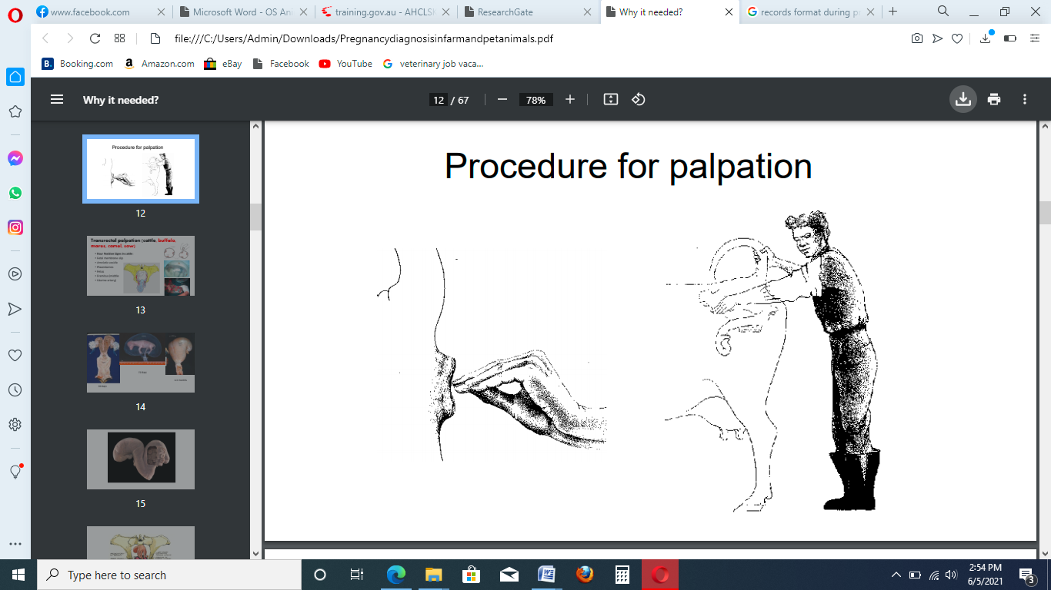 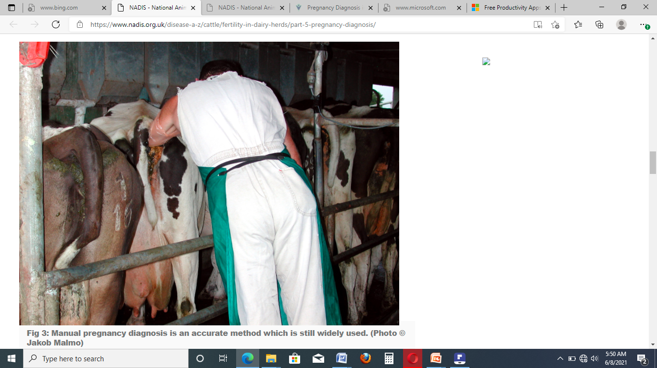

**Figure 3:** Trans-rectal palpation for pregnancy diagnosis in cow

**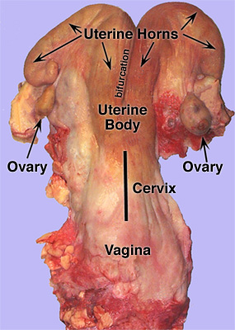**

**Figure 4**: Anatomy of female reproductive organs

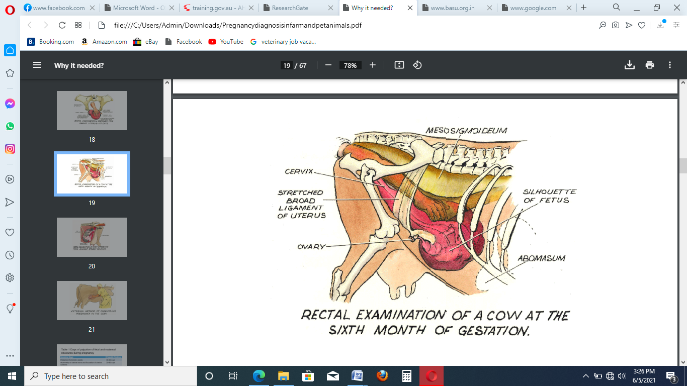

**Figure 5:** Rectal examination of pregnant cow at six months of gestation

* 1. **Palpable findings of pregnancy in cattle**

Palpable findings of pregnancy have long history in pregnancy diagnosis. Two things must be kept in mind by clinicians in making positive diagnosis of pregnancy by rectal palpations in cattle. The first is, that when the palpator in unable to detect any of the palpable characteristics mentioned herein, he must neither comment positively or negatively as both would be frustrating both to the clinician and the owner on a later date. He must better admit the fact that he is not able to detect out properly and the animal must be re-submitted for examination 15-30 days later preferably after a fasting. The second thing that clinicians must keep in mind is the accuracy of the gestation period (this is especially applicable for the 5-8 month period in cattle. An approximation of the gestation period must be conveyed to the owner rather than an accurate period. Although experienced clinicians can more precisely comment on the gestation period after an examination it is usually safe to be approximate.

Owners often consult veterinarians on the fetal viability during mid to late gestation. It is often difficult to comment positively by a single rectal palpation. Until unless characteristic changes in the uterus and fetus are palpable negative comments must better be avoided. The usual test for fetal viability during this period is the movement of the fetus in response to stimuli by the examiners hand (movement of a fetal leg when pressed by hand or suckling movements by the calf when a finger is touched in the mouth) however; this may be sometimes misleading specially when the fetus is depressed.

**Location of pregnant uterus**

The pregnant uterine horn under goes sequential changes in size, location and morphology and they form the basis for pregnancy diagnosis. The early pregnant uterus lies in the pelvic cavity in heifers, and just ahead of the pelvic brim in pleuriparous large sized cows. As it grows in size, its growth is forward so it starts descending into the abdominal cavity (approx 3½ - 4 months). At approximately 4½ - 5 months it reaches the abdominal floor and at this time only cervix is palpable within the pelvic cavity which is also drawn forward. The growth is then forward and then again upwards. The entire uterus or the fetus is therefore barely palpable during the 4 – 6½ months period and diagnosis has to be dependent on other features of pregnancy (placentomes or fremitus). After this period the fetal parts are usually palpable and clinicians find no difficulty in commenting whether the animal is pregnant or non-pregnant. During early pregnancy (day 30-60) clinicians have to depend on finding of the fetal membrane slip or the palpation of the amniotic vesicle.

The definite signs of pregnancy in the cow as determined by rectal palpation are

* palpation of enlarged uterine horn containing the placental fluids
* palpation of the amniotic vesicle
* slipping of the fetal membranes
* palpation or ballottement of the fetus
* Palpation of the placentomes
* Palpation of enlarged thin walled “whirring” uterine arteries.

**Uterine changes**

The increase in the diameter of the uterine horns is characterized by a thinning of the uterine wall and the feeling of a fluid filled structure. By 40-90 days of pregnancy, the uterus feels like a thick rubber balloon nearly filled with water. The volume of fluid increases rapidly the first 5 months of pregnancy and then increase slowly. With advancing pregnancy the non pregnant horn may also increase in size slightly.

**The amniotic vesicle**

The amniotic vesicle can be palpated with due care between 30-50 days of gestation as a movable oval object within the uterine lumen, many a times at the apex of the cornua. The vesicle is turgid, early in pregnancy but becomes flaccid with advancing gestation until days 65-70 when it is difficult to detect at all. The width of the vesicle is around 1 finger (1.5 cm) at 40-42 days of pregnancy and increases to 4 fingers (9.0 cm) at 60-62 days of gestation.

**Slipping of the fetal membranes**

The fetal membrane slip can be felt between 35-90 days of gestation (Zemjanis, 1970). The entire uterine horn must be grasped in the palm and allowed to slip while the fingers compress it gently. The allantois chorion, slip between the thumb and fingers before the uterine wall escapes. It is felt like a connective tissue band. The pressure must be gentle. The entire diameter of each uterine horn must be palpated.

**Palpation of placentomes**

The presence of placentomes is another positive sign of pregnancy and is detectable from about 75 days to term. The period of pregnancy when the uterus has descended into the abdominal cavity and the fetus is not palpable, palpation of a placentome is the surest indication that the cow is pregnant. Since there is great variation in size among individual placentomes (those nearest the fetus are the largest), their usefulness in aging a pregnancy is limited. In general, they can be detected as soft, thickened lumps in the uterine wall and are more easily detected as pregnancy advances.

**Palpation of the fetus**

The palpation of the fetus itself is a positive sign of pregnancy. Depending on the skill of the examiner and the location of the fetus, the fetus can be palpated from the time of amniotic softening (65 to 70 days) to term. However, in large sized cows the abdomen should be lifted up by a bamboo held by two attendants on either side of the abdomen to palpate a fetus during mid gestation (4½ - 6½ months). The whole of the fetus is palpable many a times only during early gestation (2 to 4 months). The size of the fetus is approximately that of a mouse or rat at 2 and 3 months and it increases to the size of a small cat at 4 months, a large cat at 5 months and a beagle dog at 6 months respectively.

The maximum fetal growth occurs during the last one to one and a half month of gestation and estimates of predicting pregnancy status depend upon the experience of the clinician and location of the fetal parts. Beyond 8 months of gestation, fetal parts (legs, head) are palpable within the pelvic cavity or just cranial to the pelvic brim. Palpation of a fetal extremity is sufficient evidence for pregnancy if other uterine findings are normal.

**Palpation of uterine artery fremitus**

The major supply of blood for the gravid uterus arrives via the uterine arteries, which enlarge considerably as pregnancy progresses. These bilateral vessels travel in the broad ligaments, just below and anterior to the iliac shafts reflecting in a cranio ventral direction. They can thus, be felt by the hand directed laterally towards the iliac shaft. These vessels are freely movable. Enlargement of the uterine artery ipsilateral to the pregnant horn is detectable after 80 to 90 days of gestation. By approximately 120 days, the blood flow within the artery increases to a point where the blood flow is palpable as a buzzing sensation, also called “thrill” or “fremitus”. By 7 to 8 months the fremitus is often palpable on the side of the non-pregnant uterine horn also. The detection of fremitus is a positive sign of pregnancy.

**Palpation of ovaries**

As the pregnancy advances ovaries may be dragged forward along with the pregnant uterus and may not be palpable beyond the four to five months.

**Vaginal changes**

During pregnancy the vagina usually develops a pale, dry sticky mucus membrane. The cervix is closed and the cervical (mucus) seal covers the external os by day 40 to 120 of pregnancy. Slight degree of vaginal discharge is evident in some cows beyond 5 months of pregnancy but the cervical seal liquefies only prior to parturition or abortion and is discharged in strings.

1. **Ultrasonography**

Ultrasonic imaging technology allows non-invasive visualization of the reproductive tract and has allowed the study of dynamic interactions. Accurate pregnancy diagnosis could be achieved based on the recognition of a proper embryo with a beating heart, at between 26 and 34 days, by using ultrasonography in cattle.

**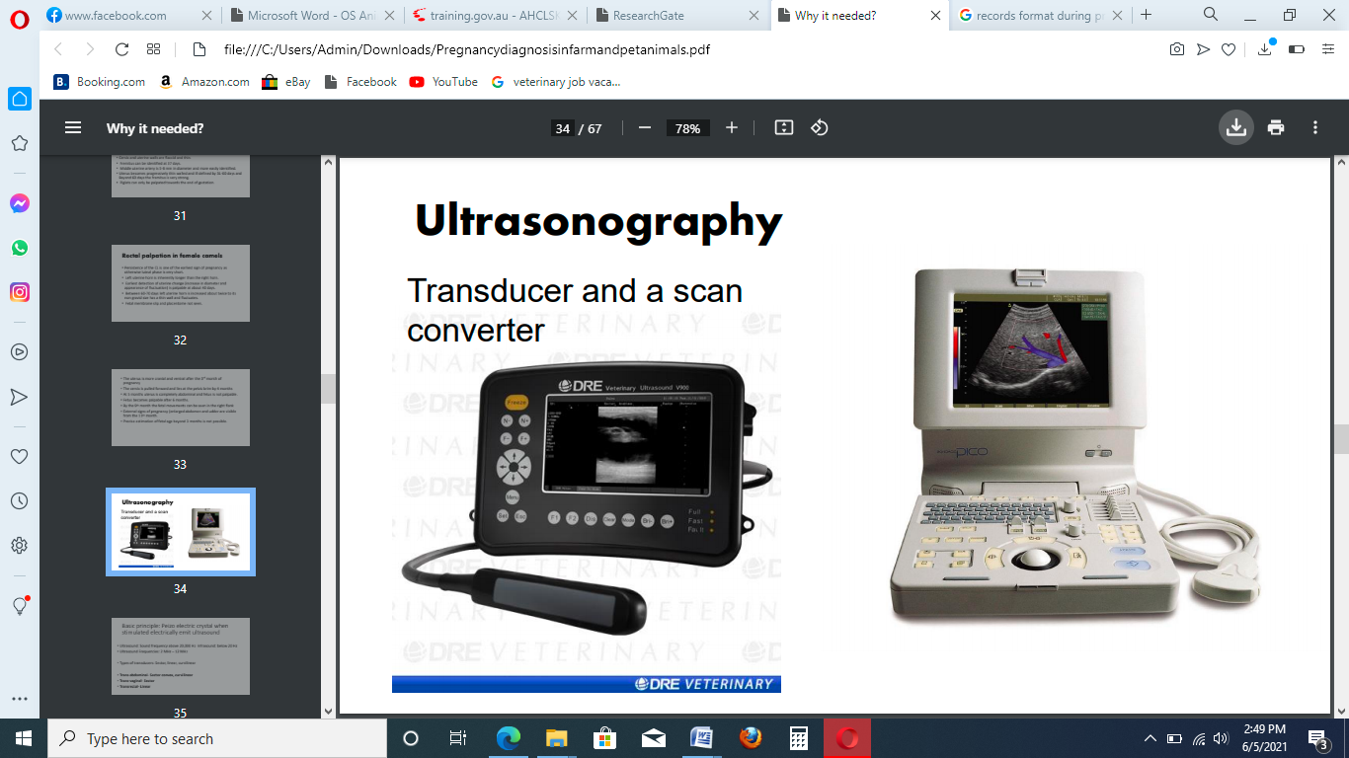**

**Figure 6:** Ultrasonic machine used to test pregnancy diagnosis in animals

1. **Indirect Methods of pregnancy diagnosis**

Indirect methods of early pregnancy diagnosis use qualitative or quantitative measures of reproductive hormones in the laboratory at specific stages after AI or detect conceptus specific substances in maternal body fluids as indirect indicators of the presence of a viable pregnancy. Currently available indirect methods of pregnancy diagnosis include measurement of endocrine hormones such as progesterone estrone sulphate and pregnancy specific proteins such as pregnancy-associated glycoproteins, the early pregnancy factor and interferon-tau. Progesterone maintains the uterine endometrium in a state which supports embryonic development, implantation, and foe- toplacental development. Progesterone concentrations vary with the stage of the estrous cycle which makes it one of the most commonly studied reproductive hormones in bovine ruminants for pregnancy detection and ovarian activity.

Measurement of progesterone is an indirect method for pregnancy diagnosis in many livestock species including cattle, buffaloes, sheep, and goats. Measuring milk progesterone is the test that is most likely to replace rectal palpation. In general, the concentration of progesterone hormone is variable with the stage of pregnancy. A single sample taken 24 days after service will accurately identify non-pregnant cows; >95% of cows with low progesterone will not be pregnant.

Estrone Sulphate: Estrone sulphate is a conjugated steroid product of estrone, present predominantly in the bovine placentomes and it is the major estrone present in the fetal (allantoic and amniotic) fluids and maternal peripheral plasma of cows with measurable quantities detectable by day 52 onwards till the end of gestation. Its concentrations increase from day 60 and plateau around day 150 after insemination. However, reliable pregnancy detection is possible only after day 100 of gestation and therefore this test can only detect late pregnancy. Concentration of estrone sulphate in the maternal body fluids is a useful indicator for the placental functions especially those related to embryonic growth.

**Other methods of pregnancy diagnosis**

The visual methods of pregnancy diagnosis include observation of the following signs on animals.

* Cessation of oestrous cycle after artificial/ natural insemination.
* Sluggish and docile behaviour.
* Fattening tendency particularly during early pregnancy.
* Gradual drop in milk yield (after 5 months)
* Gradual increase in body weight.
* Gradual increase in the size of the abdomen.
* Flanks become hollow and spine appears more prominent.
* The size of mammary glands or udder begins to increase from about 5th months of gestation in heifers, while in older cows it is usually observed just 2-3 weeks before parturition.
* In few animals, a prepartum udder oedema and umbilical oedema is noticed.
  1. **Differential Diagnosis of Pregnancy in Bovine**

There are many cases in which uterus remain distended and an in experienced person may make false positive diagnosis.

**Pyometra:** Is the presence of pus in the uterus

* Pus remains present in the uterus.
* Both the uterine horns remain equally distended while in pregnancy, horns remain asymmetrical.
* Fremitus is absent in pyometra because there is no need to supply extra blood.
* Thick uterine wall and lack of tone while in pregnancy, thin and tonic uterine wall.
* No slipping of foetal membrane.

**Mucometra or hydrometra:** is excess accumulation of mucus or fluid in the uterus

* No slipping of foetal membrane
* No placentomes
* Failure of progressive development of uterus as in a normal pregnancy

**Mummification:** is solid mass tightly surrounded by uterine wall.

* No placental fluids.
* Intra-abdominal uterus may be confused with pregnancy.
* No increase in the size of abdomen.

Apart from these conditions, an inexperienced person may confuse with visceral organs of the animal. Anatomically, there is no reason for confusing a pregnant uterus with such structures. Careful rectal examination, consideration of the anatomical structures and relationships of these organs and their consistency will prevent erroneous diagnosis.

* 1. **Pregnancy Diagnosis in Small Ruminants**

A simple and reliable technique for diagnosing pregnancy and detection of multiple pregnancy in small ruminants (sheep & goat) is of paramount importance

**Abdominal palpation:**

Procedure:

1. Withhold feed and water for 12-24 hrs. before abdominal palpation.
2. The ewe or doe is restrained in a sitting position.
3. One hand is placed against the left abdomen.
4. Right abdomen is palpated by using finger-tips.
5. The foetus is felt as a floating body when it is pushed away and then returned to the finger-tips.
6. Raise the abdomen just in front of udder by taking the hand between hind legs whilst with other hand, push the abdomen from flank towards the hand used to lift. Repeat with the other side by changing the hand for lifting and pushing. The foetus is felt as a floating body in pregnant animal.

Other methods of pregnancy diagnosis in small ruminant is using of probe placement for trans-abdominal ultrasonography. This technique is employed by placing probe near to the mammary gland and observing the image of the fetus. Figure below shows placement for trans-abdominal ultrasonography on sheep.

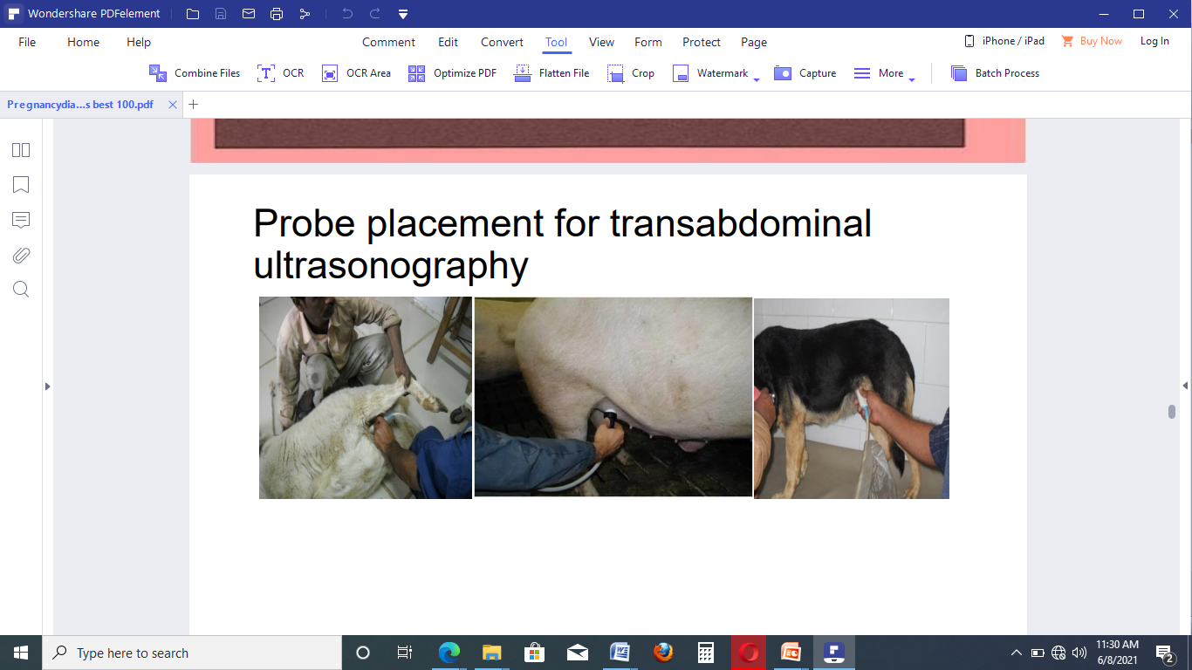

Probe

**Figure 7:** Placement for trans-abdominal ultrasonography on sheep

|  |
| --- |
| **Self check 3 - Written exam** |

**Directions:** Answer all the questions listed below. Use the Answer sheet provided in the next page:

**Short answer questions**

1. Prepare the necessary equipment, materials and tools used for pregnancy diagnosis(4 points)
2. Perform pregnancy diagnosis in dairy cow(6 points)

You can ask your teacher for the copy of the correct answer

***Note:* Satisfactory rating – 5 points Unsatisfactory - below 5 points**

You can ask you teacher for the copy of the correct answers.

**Answer Sheet**

Score = \_\_\_\_\_\_\_\_\_\_\_

Rating: \_\_\_\_\_\_\_\_\_\_\_\_

Name…………………………………………… ID………………………… Date…….

|  |
| --- |
| Operation sheet 1 - Carrying out pregnancy diagnosis procedure |

Step by step trans-rectal pregnancy diagnosis of pregnant animals

1. Preparation of necessary equipments necessary for pregnancy diagnosis
2. Proper restraining of the animals
3. Wearing of proper clothing and also proper lubrication
4. The operator must make a cone of his hand and push it inside the rectum
5. The anal sphincter dilates and the hand enters inside the rectum
6. The feces must be removed without taking out the hand completely
7. Palpate the cervix. The cervix which is a hard round to oval or sometimes caudally enlarged disfigured structure is the land mark for location of genital structures in cattle and buffaloes.
8. These structures can be pulled caudally when located at the pelvic brim or further, by retracting the broad ligament or hooking the inter-cornual ligament by the index finger.
9. When the pregnancy is beyond 60 days this cannot usually be done and the operator has to move his hand further in the rectum, so as to locate the intra-abdominally placed uterus and palpate other features diagnostic of pregnancy.

|  |
| --- |
| LAP TEST - Performance Test |

Name………………………………. ID…………………………….. Date…………………………………….

Time started: \_\_\_\_\_\_\_\_\_\_\_\_\_\_\_\_\_\_\_\_\_\_\_\_ Time finished: \_\_\_\_\_\_\_\_\_\_\_\_\_\_\_\_

**Instructions:** Given necessary templates, tools and materials you are required to perform the following tasks within 30 minutes. The project is expected from each student to do it.

**Task 1- Prepare personal protective equipments used for pregnancy diagnosis**

**Task II- Perform pregnancy diagnosis in cow**

|  |
| --- |
| Information sheet 4 - Identify stage of pregnancy |

* 1. **Stages of pregnancy in bovine**
  2. **.1 Introduction**

During the fetus stage, continued attachment takes place at the numerous caruncles lining the uterus. These attachments provide transfer of nutrients and waste materials for the developing fetus. Birth occurs approximately 280 days after fertilization.

First month (Negative stage)

* Both the uterine horns are symmetrical.
* Uterine horns are intrapelvic.
* Feel of uterine horn is normal.
* One of the ovaries exhibits Corpus luteum .
* Cervix remains closed.

Second month (31st to 60th days) or small sac stage

* Uterus is usually intra-pelvic and palpable from all the sides.
* Uterus is tonic.
* Pregnant horn is 2-4 times enlarged.
* Slippery feel of foetal membrane when horn is palpated between fingers (double wall) from the 5th week of pregnancy in heifers and from the 6th week in cows (placental palpation).
* Uterine wall thinner than normal due to increased diameter of uterine horn.
* Ovaries are at normal position and one of the ovary exhibits pregnancy CL or corpus luteum verum, which differs from periodic corpus luteum in not having a neck.
* Cervix is closed and normal in position.

Third month (61st - 90th days) or large sac stage:

* Now, uterus hangs on the brim of pelvis and is palpable from only three sides.
* Uterus is tonic
* Pregnant horn is further enlarged.
* Thinning of uterine wall continues (very thin).
* Rebound effect is detectable.
* Ovaries are pulled forward.
* Cervix is stretched or pulled forward.
* Heaviness is felt when cervix is bulled by examiner.

Fourth month (91st - 120th days) or Balloon stage

* Uterus is abdominal.
* Thinning of uterine wall continues.
* Cotyledons detectable.
* Fluctuations can be felt.
* Fremitus (+) can be felt.
* Cervix is located beyond/ at pelvic brim (reason-due to increase in weight of uterus, so it is pulled forward).
* Ovaries are pulled forward and are out of reach i.e. in abdominal cavity.

Fifth month (121st - 150th days) or sinking stage.

* Uterus is sinking in abdomen.
* Foetus and fluctuations are felt.

Sixth to seventh month (15pt -210thdays)

* Uterus is entirely abdominal.
* Foetus sinks more deep in the abdominal cavity and is not palpable.
* But in the last of seventh month, foetus starts to come near the pelvic cavity and is easily palpable.

Eight to ninth month (21pt - 270th days):

* Foetus comes again nearer to the pelvic cavity.
* Foetal parts can be clearly felt.
* Strong foetal movement is palpable.

Generally pregnancy stage can be categorized into three stages

1. First trimester: is stage of pregnancy from first week up to three months of pregnancy
2. Second trimester: is stage of pregnancy from fourth months up to six months of pregnancy
3. Third trimester: is stage of pregnancy from seven months up to parturition

|  |
| --- |
| Self check 4 - Written exam |

**Directions:** Answer all the questions listed below. Use the Answer sheet provided in the next page:

**Short answer question**

1. Define stage of pregnancy in bovine species(2 points)
2. What are the three basic stages of pregnancy in cow(2 points)

***Note:* Satisfactory rating – 2 points Unsatisfactory - below 2 points**

You can ask you teacher for the copy of the correct answers.

You can ask your teacher for the copy of the correct answers

**Answer Sheet**

Score = \_\_\_\_\_\_\_\_\_\_\_

Rating: \_\_\_\_\_\_\_\_\_\_\_\_

Name…………………………………………… ID………………………… Date…….

|  |
| --- |
| Information sheet 5 - Identify growth postural and positional abnormalities of pregnancy |

* 1. **Growth postural and positional abnormalities of pregnancy**
  2. **.1 Introduction**

Abnormal Presentation, Position and Posture of Foetus

Presentation: It is relationship between longitudinal axis of dam with the longitudinal axis of foetus and parts present towards birth canal. The presentation may be divided into three parts:

* Longitudinal presentation (normal)
* Transverse presentation (abnormal)
* Vertical presentation (abnormal)

**Longitudinal presentation**: When longitudinal axis of dam is parallel to the longitudinal axis of vertebral column of foetus, the presentation is called longitudinal presentation. It is of two types:

* Anterior longitudinal presentation: When foetus is in longitudinal presentation and its anteriormostparts i.e. both fore limbs and head are present towards birth canal, the presentation is called anterior longitudinal presentation.
* Posterior longitudinal presentation: When foetus is in longitudinal presentation and posterior parts of the foetus i.e. both hind limbs are present towards birth canal, the presentation is called posterior longitudinal presentation.
* Transverse presentation: When longitudinal axis of foetus forms a right angle with the long axis of dam in transverse plane, the presentationis is called as transverse presentation. It is of three types:

Dorso-transverse or dorsa-lumbar: When longitudinal axis of foetus forms a right angle with the long axis of dam in transverse plane and dorsum (vertebral column) of the foetus becomes convex and faces the pelvic inlet, the condition is called dorso-transverse presentation or when foetus is in transverse presentation and its dorsum faces the pelvic inlet, the presentation is called dorso-transverse presentation.

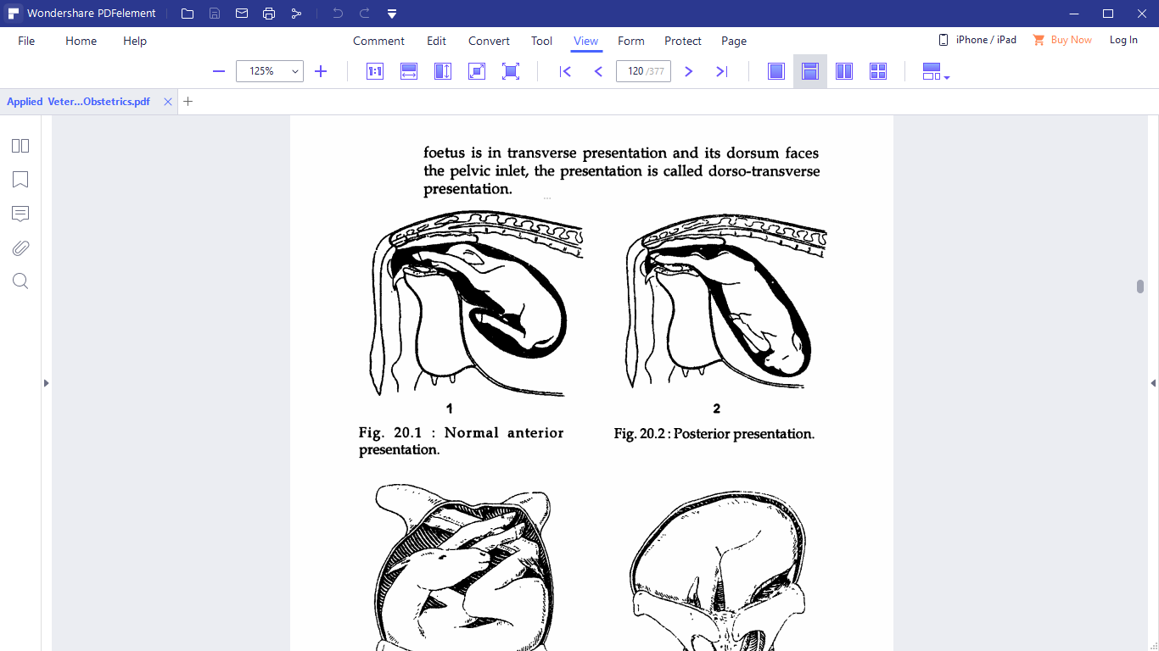

**Figure 9:** Normal posterior presentation

**Figure 8:** Normal anterior presentation

**Vertical presentation:** When longitudinal axis of foetus forms the right angle with long axis of dam in vertical plane, the presentation is called vertical presentation. It is of three types:

* Ventro-vertical: When foetus is in vertical presentation and its ventral portion i.e. sternum and abdomen faces pelvic inlet, the presentation is known as ventro-vertical presentation.
* Dorso-vertical: When foetus is in vertical presentation and its dorsum (i.e. vertebral column) faces pelvic inlet, the presentation is called dorso-vertical presentation.
* Latero-vertical: When foetus is in vertical presentation and its lateral surface faces pelvic inlet, the presentation is called latero-vertical presentation.

**POSITION:** It is the relationship between vertebral column of foetus with the four quadrants of pelvic inlet of the dam. Or It is relationship of the dorsum (thoracic and cervical vertebrae) in anterior longitudinal presentation, lumbar vertebrae in posterior longitudinal presentation or head (cephalo) in transverse presentation to the quadrants of maternal pelvis (sacrum, right ilium, left ilium and pubis).

**POSTURE**: It is relationship between movable appendages of foetus with its own body.

|  |
| --- |
| Self check 5 - Written test |

**Directions:** Answer all the questions listed below. Use the Answer sheet provided in the next page:

**Short answer questions**

1. Define positional, presentation and postural abnormalities of fetus(5 points)
2. Explain causes of abnormal presentation and position of fetus(3 points)

***Note:* Satisfactory rating – 2 points Unsatisfactory - below 2 points**

You can ask you teacher for the copy of the correct answers.

You can ask your teacher for the copy of the correct answers

**Answer Sheet**

Score = \_\_\_\_\_\_\_\_\_\_\_

Rating: \_\_\_\_\_\_\_\_\_\_\_\_

Name…………………………………………… ID………………………… Date…….

|  |
| --- |
| Information sheet 6 - Keeping Record |

**6.1 Keeping Record, documentation and reporting**

Record keeping in pregnancy diagnosis is necessary to give feed back to the owners and reporting to the concerned bodies.

The critical considerations when looking at pregnancy testing data are:

* What was the pregnancy rate or conception rate?
* What was the pattern of conceptions over the mating period?
* What does the pregnancy data mean for future planning and management?
* What does the pregnancy data mean for future business performance?

The following recording format is used during pregnancy diagnosis in animals.

**Table 2:** Format used during Pregnancy diagnosis works

Region \_\_\_\_\_\_\_wereda \_\_\_\_\_\_\_\_kebele \_\_\_\_\_\_\_\_

|  |  |  |  |  |  |  |
| --- | --- | --- | --- | --- | --- | --- |
| s.no | Cow ID | No.of service | Last date of insemination | Bull used(bull ID) | PD Resulr(+/-) | Remarks |
|  |  |  |  |  |  |  |
|  |  |  |  |  |  |  |
|  |  |  |  |  |  |  |

Name of PD test technician\_\_\_\_\_\_\_\_\_\_\_\_\_\_\_\_\_ Signature\_\_\_\_\_\_\_\_\_\_\_\_\_Date\_\_\_\_\_\_

**Other data to collect when pregnancy testing**

* **Heifer growth rates:** Heifer weights should be monitored from weaning to ensure they will achieve the target or critical mating weight. This allows early intervention if the heifers growth fall below the desired level.
* **Breeder body condition:** Breeder body condition prior to calving is the major determinant of conception rates.

|  |
| --- |
| Self check 6 - Written exam |

**Directions:** Answer all the questions listed below. Use the Answer sheet provided in the next page:

**Short answer questions**

1. What is the use of record keeping in pregnancy diagnosis in animals(3 points)
2. Write points to be considered when recording pregnancy diagnosis data(3 points)

***Note:* Satisfactory rating – 3 points Unsatisfactory - below 3 points**

You can ask you teacher for the copy of the correct answers.

You can ask your teacher for the copy of the correct answers

**Answer Sheet**

Score = \_\_\_\_\_\_\_\_\_\_\_

Rating: \_\_\_\_\_\_\_\_\_\_\_\_

Name…………………………………………… ID………………………… Date…….

|  |
| --- |
| Information sheet 7- Disposing wastes |

**7.1 Definition of wastes**

Wastesare unwanted or unusable materials. Waste is any substance which is discarded after primary use, or is worthless, defective and of no use. A waste product may be came a by product, joint product or resource through an invention that raises a waste product’s value. Waste which commonly found during pregnancy diagnosis is disposable plastic or rubber full arm sleeves (arm length gloves). The pregnancy diagnosis practitioner’s must collect, store and remove wastes in the work place. When waste is generated, it must be disposed of properly.

All veterinary practices should register their premises, keep a Waste Register, and use Consignment Notes, as well as keeping this information for three years minimum. General waste should be veterinary risk assessed. The practice should ask the following questions:

* Does the material arise from an animal that has a disease caused by a micro-organism, such that the material is contaminated with that micro-organism?
* Is there any other potential risk of infection?

Waste containing viable micro-organisms or other toxins is labelled as infectious, clinical waste. This waste must be disposed of correctly because it is reliably believed to cause disease in humans. Non-hazardous veterinary wastes are most commonly observed during pregnancy diagnosis. Veterinary non-hazardous waste is waste other than sharps that is not hazardous or clinical but may cause offense to the senses in some way. This waste will have undergone assessment that determined that it was not a risk to human or animal health. **Offensive waste** could include swabs, masks and gloves, animal bedding and animal faeces. Offensive waste should be disposed of in landfill or in other suitable permitted facilities. Waste materials should be disposed properly in a designated place. You can dispose by burning or by collecting and placing a waste material in designated pit.

|  |
| --- |
| Self check 7 - Written exam |

**Directions:** Answer all the questions listed below. Use the Answer sheet provided in the next page:

**Short answer questions**

1. Define offensive waste(2 points)
2. Explain wastes in veterinary clinic(4 points)

***Note:* Satisfactory rating – 3 points Unsatisfactory - below 3 points**

You can ask you teacher for the copy of the correct answers.

You can ask your teacher for the copy of the correct answers

**Answer Sheet**

Score = \_\_\_\_\_\_\_\_\_\_\_

Rating: \_\_\_\_\_\_\_\_\_\_\_\_

Name…………………………………………… ID………………………… Date…….

|  |  |
| --- | --- |
| **LG #68** | LO # 4- Carry out post pregnancy testing clean up procedure |

## Instruction sheet

This learning guide is developed to provide you the necessary information regarding the following content coverage and topics:

* Identifying Animals diagnosed
* Consigning all animals to their destination
* Disposing debris and veterinary medicine containers
* Monitoring of animals post pregnancy diagnosis

This guide will also assist you to attain the learning outcomes stated in the cover page. Specifically, upon completion of this learning guide, you will be able to:

* Identify pregnant and non-pregnant animals accurately
* Return pregnancy tested animals to paddocks/pens
* Dispose debris and veterinary service waste from pregnancy diagnosis operations
* Dispose waste according to recommended hygienic standards
* Carry out regular monitoring of animals for post-pregnancy diagnosis

**Learning Instructions:**

1. Read the specific objectives of this Learning Guide
2. Follow the instructions described below
3. Read the information written in the “Information Sheets”. Try to understand what are being discussed. Ask your trainer for assistance if you have hard time understanding them
4. Accomplish the “Self-checks” which are placed following information sheets
5. Ask from your trainer the key to correction (key answers) or you can request your trainer to correct your work. (You are to get the key answer only after you finished answering the Self-checks)
6. If you earned a satisfactory evaluation proceed to next information sheet
7. If your performance is unsatisfactory, see your trainer for further instructions

|  |
| --- |
| Information sheet 1 - Identifying diagnosed animals as pregnant or not pregnant accurately |

* 1. **Identify pregnant and non-pregnant animals accurately**

Actual pregnancy diagnoses need palpation of the entire length of the uterine horn to determine their consistency. If the horns are empty they will have a meat-like consistency. If there is a pregnancy, fluids will be present in one or both horns. A common mistake made by beginners is that of attempting to slip foetal membranes without determining the uterine contents. Sometimes a false slip is obtained and an open cow is called pregnant.

Four criteria can be applied to declare a cow pregnant:

1. palpation of the amniotic fluid
2. slip of foetal membranes
3. palpation of the foetus
4. palpation of placentomes(caruncles)

Palpation of the amniotic fluid is possible from about 30 -70 days of gestation. Before days 30 the amniotic vesicle is too small and after day-70 it becomes too large and too soft for palpation. Palpation of the amnion should not be done as a routine to determine pregnancy because of the risk of rupturing either the amniotic vesicle or the foetal heart sac; rupture will result in abortion. After 50 days the risk increases.

The size and position of the uterus may be helpful indicators and may suggest pregnancy, but one should not call a cow pregnant unless a positive sign of pregnancy is detected. The foetus cannot be palpated until the amnion has become flaccid enough to allow manipulation. This is usually the case at about 75 days. From then onwards palpation of the foetus is valuable for diagnosis and for estimating the duration of pregnancy. In many cows the foetus is out of reach between about five and seven months.

To realize the productive potential of the animals, maximum reproductive efficiency must be achieved. This implies maintaining a postpartum barren interval of close to 60 days for dairy cows. To this end, dairymen may utilize milk progesterone analysis 21 to 23 days following insemination to identify cows not pregnant earlier than would be possible by uterine palpation. The hormone progesterone is secreted by the corpus luteum (CL) and is responsible for maintaining the pregnancy. If cow is pregnant, or a fluid filled uterine horn signals pregnancy, progesterone persists beyond the next heat cycle.

Knowledge of the associations of pregnancy-related hormones or pregnancy-specific antigens profiles with various management- and animal-related factors throughout gestation is valuable for accurately diagnosing and monitoring pregnancy. Though rectal palpation is the only method employed for pregnancy diagnosis in Ethiopia, the introduction or wider application of other more up-to- date techniques (ultrasonography and hormone or pregnancy-specific antigen analysis) could be possible in the near future for research purposes and for pregnancy diagnostic purposes, at least in commercial large-scale dairy farms in Ethiopia.

Accuracy of the laboratory pregnancy test is expressed routinely as the percent agreement between laboratory diagnosis of pregnancy based on the concentration of progesterone in milk and diagnosis by uterine palpation or observed recurrence of estrus more than 23 days after insemination. It has been a consistent finding that accuracy of the laboratory diagnosis is 75 to 85% for pregnant diagnoses and 95 to 100% for not pregnant diagnoses.

Most of these milk progesterone programs have employed a specified concentration of progesterone in milk to distinguish between only two categories, pregnant and non-pregnant cows, and used diagnosis after uterine palpation as the reference standard.

|  |
| --- |
| Self check 1 - Written exam |

**Directions:** Answer all the questions listed below. Use the Answer sheet provided in the next page:

**Short answer questions**

1. What are the four basic criteria to declare cow to be pregnant?(4 points)
2. Accurate pregnancy diagnosis of pregnant animals is determined by palpation of which parts of female reproductive tract?(2 points)

***Note:* Satisfactory rating – 3 points Unsatisfactory - below 3 points**

You can ask you teacher for the copy of the correct answers.

You can ask your teacher for the copy of the correct answers

**Answer Sheet**

Score = \_\_\_\_\_\_\_\_\_\_\_

Rating: \_\_\_\_\_\_\_\_\_\_\_\_

Name…………………………………………… ID………………………… Date…….

|  |
| --- |
| Information sheet 2 - Consigning all animals to their destination or return to pens/paddock |

* 1. **Consign all animals to pens/paddock**

What is animal handling pens and paddock?

A **pen** is an enclosure for holding livestock. It may also perhaps be used as term for enclosure for other animals such as pets that are unwanted inside the house. The term describes types of enclosures that may confine one or many animals. Construction and terminology vary depending on the region of the world, purpose, animal species to be confined, local materials used and tradition. **Paddock i**s a small, usually enclosed field near a stable or barn for pasturing or exercising animals

After completing pregnancy diagnosis, animals should be returned back to the holding pens or paddock. Inside paddock/holding pens animals must be considered for adverse effect of pregnancy diagnosis. The responsibility of monitoring should provide for animal attendants in the paddock.

|  |
| --- |
| Self check 2 - Written exam |

**Directions:** Answer all the questions listed below. Use the Answer sheet provided in the next page:

**Short answer questions**

1. Define the difference between pens and paddock(4 points)

***Note:* Satisfactory rating – 2 points Unsatisfactory - below 2 points**

You can ask you teacher for the copy of the correct answers.

You can ask your teacher for the copy of the correct answers

**Answer Sheet**

Score = \_\_\_\_\_\_\_\_\_\_\_

Rating: \_\_\_\_\_\_\_\_\_\_\_\_

Name…………………………………………… ID………………………… Date…….

|  |
| --- |
| Information sheet 3 - Disposing debris and veterinary medicine containers in pregnancy testing procedures |

* 1. **Dispose debris and veterinary medicine containers waste**

Knowing how to properly dispose of waste generated by your practice is essential to protect the health of people, animals, and ecosystems.  The keys to proper disposal decisions include:

* Awareness of the options and restrictions for disposal of individual items in your area
* Knowing which authorities have oversight over which aspects and items so that you know who to ask when questions come up
* Disposal instructions on Material Safety Data Sheets (MSDS) and product inserts
* Disposal policy for the practice including all of the above
* Training

|  |
| --- |
| Self check 3 - Written exam |

**Directions:** Answer all the questions listed below. Use the Answer sheet provided in the next page:

**Short answer question**

1. Write the types of waste disposed in veterinary clinic and/or farm during pregnancy diagnosis(4 points)
2. You can ask your teacher for the copy of the correct answers

***Note:* Satisfactory rating – 2 points Unsatisfactory - below 2 points**

You can ask you teacher for the copy of the correct answers.

**Answer Sheet**

Score = \_\_\_\_\_\_\_\_\_\_\_

Rating: \_\_\_\_\_\_\_\_\_\_\_\_

Name…………………………………………… ID………………………… Date…….

|  |
| --- |
| Information sheet 4 - Carrying out regular monitoring of animals post testing evidence of physical damage or injury |

* 1. **Carry out regular monitoring of animals post pregnancy diagnosis**

It is likely that most cows experience some degree of hemorrhage during rectal examination, although it is usually not grossly detectable. Bacteremia can also occur after rectal palpation, but is probably not a clinically significant problem. These observations generate concern that the use of a common examination sleeve for rectal palpation of more than one cow may result in transmission of disease from one animal to another. Intra-rectal inoculations of whole blood and simulated rectal palpation using a sleeve inoculated with whole blood have resulted in transmission of bovine leukemia virus (BL V) from viremic to sero-negative cattle. This issue, and the possibility that other diseases ( eg., anaplasmosis or paratuberculosis) may be transmitted in a similar fashion are certainly a concern for veterinarians who offer reproductive herd health programs. It may be wise to institute a practice of using individual sleeves for rectal examination, especially in herds that are involved in BL V or Johne's eradication programs.

Rectal palpation of an animal suffering from fever should be extremely gentle or better avoided as the blood vessels are more fragile and bleed easily. Similarly examining an animal with rectal tear or rectal fistula is hazardous. Whenever, a clinician notices such conditions he must bring them to the notice of the owner or else he would blame the clinician. Rectal fistulas are an emergency in a mare and immediate treatment including broad spectrum oral and parental antibiotics and anti-inflammatory drugs must be given along with laxatives or else the mare may develop a fatal peritonitis. The fistula/tear may be palpable as a blind pouch or a slit in the rectal mucosa that bleeds when the hand is forwarded through these openings may lead to an increase in injury risk.

Precautions during rectal palpation

When performed gently and carefully rectal palpation is a non-invasive procedure. The following points would be helpful in minimizing damage to the animal and the examiner as well.

* Ruthless movements of the hand in the rectum should be avoided. Avoid palpations during a peristaltic wave.
* Examiners must trim their nails and avoid using dirty soiled sleeves.
* Rectal examination without a sleeve must be avoided specially in mares to avoid contracting diseases and obnoxious odors. Sleeves must be replaced after examination of 2-5 animals, or better after each examination.
* Compared to cattle rectal palpation in buffaloes must be gentle as the rectal mucosa is more fragile and bleed easily.
* Uncareful palpation of the uterine horns with undue pressure can cause rupture of the amniotic vesicle and loss of an early pregnancy and hence this must be avoided.

|  |
| --- |
| Self check 4 - Written exam |

**Directions:** Answer all the questions listed below. Use the Answer sheet provided in the next page:

**Short answer questions**

1. Describe problems that might be encountered post-pregnancy diagnosis(2 points)
2. What are the precautions to be undertaken during rectal pregnancy diagnosis in cow?(4 points)

You can ask your teacher for the copy of the correct answers

***Note:* Satisfactory rating – 2 points Unsatisfactory - below 2 points**

You can ask you teacher for the copy of the correct answers.

**Answer Sheet**

Score = \_\_\_\_\_\_\_\_\_\_\_

Rating: \_\_\_\_\_\_\_\_\_\_\_\_

Name…………………………………………… ID………………………… Date…….

# References

**Book and scientific journal**

1. Andualem T.(2015): A review on cattle husbandry practices in Ethiopia. International Journal of Livestock Production
2. Ashok K. Balhara, Meenakshi Gupta, Surender Singh, Ashok K. Mohanty, and Inderjeet Singh (2013): Early Pregnancy Diagnosis in Bovines: Current Status and Future Directions. The Scientific World Journal
3. Bart Gietema(2004): Reproduction in dairy cattle 2nd edition
4. Desalegn G/Medhin, Merga Bekana, Azage Tegegne and Kelay Belihu (2007): Status of Artificial Insemination Service in Ethiopia. Ethiopian Society of Animal Production proceeding
5. Fikre Lobago (2007): Reproductive and Lactation Performance of Dairy Cattle in the Oromia Central Highlands of Ethiopia with Special Emphasis on the Pregnancy Period. Doctoral thesis.
6. Fricke M., Ricci A., Giordano J. and Paulo Carvalho. (2018): Methods for and Implementation of Pregnancy Diagnosis in Dairy Cows
7. G N Purohit (2019): Pregnancy Diagnosis in domestic farm and pet animals
8. Matt Lucy, Jacob Green, and Scott Poock (2011): Pregnancy Determination in Cattle: A Review of Available Alternatives. Proceedings, Applied Reproductive Strategies in Beef Cattle, August 31 – September 1, 2011; Joplin, MO
9. Natnael B., Mekeonnen A., Nejash A. and Wahid M. Ahmed.(2016): Pregnancy Diagnosis in Cattle for Fertility Management: A Review
10. Pradeep Kumar(2009): Applied Veterinary Gynaecology and Obstetrics First edition, Published by International Book Distributing Co.
11. Purohit G. (2010): Methods Of Pregnancy Diagnosis In Domestic Animals: The Current Status
12. Samuel Uchenna Felix. Conception and Gestation in Domestic Animals and Various Factors Influencing Them: A Review. Dairy and Vet Sci J. 2018; 5(2)
13. Thomas F. Fletcher and Alvin F. Weber.(2013): veterinary developmental anatomy(embryology).

**Website reference**

1. <http://www.swa.gov.au>
2. <http://wwww>. [Pregnancy Diagnosis in Cow (veterinarysciencehub.com)](http://veterinarysciencehub.com/pregnancy-diagnosis-in-cow/)
3. <https://www.researchgate.net/publication/330292329>
4. <https://www>. blink.ucsd.edu/safety/research-lab/vivarium/occupational.html#risk)
5. http://www.alpacaregistry.net/journal/spr2000\_03.html
6. <http://www.dps.ufl.edu/hansen/protocols/palpation.manual.htm>
7. http://www.[NADIS - National Animal Disease Information Service](https://www.nadis.org.uk/disease-a-z/cattle/fertility-in-dairy-herds/part-5-pregnancy-diagnosis/).org.uk
8. <http://www.webmedcentral.com/article_view/1305>

**Acknowledgement**

We wish to extend thanks and appreciation to the many representatives of TVET instructors and respective, and Oromia TVET expertise donate their time and knowledge for the development of this Teaching, Training and Learning Materials (TTLM).

We would like also to express our appreciation to **Holeta Polytechnic College** and the **World Bank Project** who made their effort by organizing, planning, and financial supporting for development of this Teaching, Training and Learning Materials (TTLM) with required standards and quality possible. This Teaching, Training and Learning Materials (TTLM) was developed on June 2021 at Adama, Pan-Afric Hotel.

**The trainers who developed the learning guide**

|  |  |  |  |  |  |  |
| --- | --- | --- | --- | --- | --- | --- |
| **No** | **Name** | **Qualification** | **Educational background** | **TVET College** | **Region** | **E-mail** |
| **1** | Dr. Addisu Bedashu | A | DVM | Holeta  PTC | Oromia | addisubedashu@gmail.com |
| **2** | Dr. Boki Negesa | A | DVM | Holeta  PTC | Oromia | bokanegesa@gmail.com |
| **3** | Dr. Abate Worku | A | DVM | Holeta  PTC | Oromia | abateworku48@gmail.com |
| **4** | Dr. Derere Dejene | A | DVM | Kombolcha TVET | Oromia | deraradejene@yahoo.com |
| **5** | Dr. Bikila Imiru | B | DVM | Chancho TVET | Oromia | bikilaaimmiruu59@gmail.com |
| **6** | Dr. Milkessa Tesema | A | DVM | Chancho TVET | Oromia | mengistut38@gmail.com |
| **7** | Dr. Kumera Lamesa | B | DVM | Bako PTC | Oromia | kumelame@gmail.com |